Task on CloudFront & Route 53
- Configure VPC peering in cross regions.
Steps:
Create VPC-1 (Region: us-east-1)
Go to AWS Console → VPC → Select Region us-east-1
Create Subnet in VPC-1
Create VPC-2 (Region: us-east-2)
Go to AWS consoleVPC → Create VPC Select Region us-east-2
Create Subnet in VPC-2
Create VPC Peering Connection
Go to VPC → Peering Connections → Create Peering Connection
Enter:
Name: Peering-virginia-ohio
Requester VPC: VPC-1
Requester Region: us-east-1
Accepter VPC: VPC-2
Accepter Region: us-east-2
Click Create
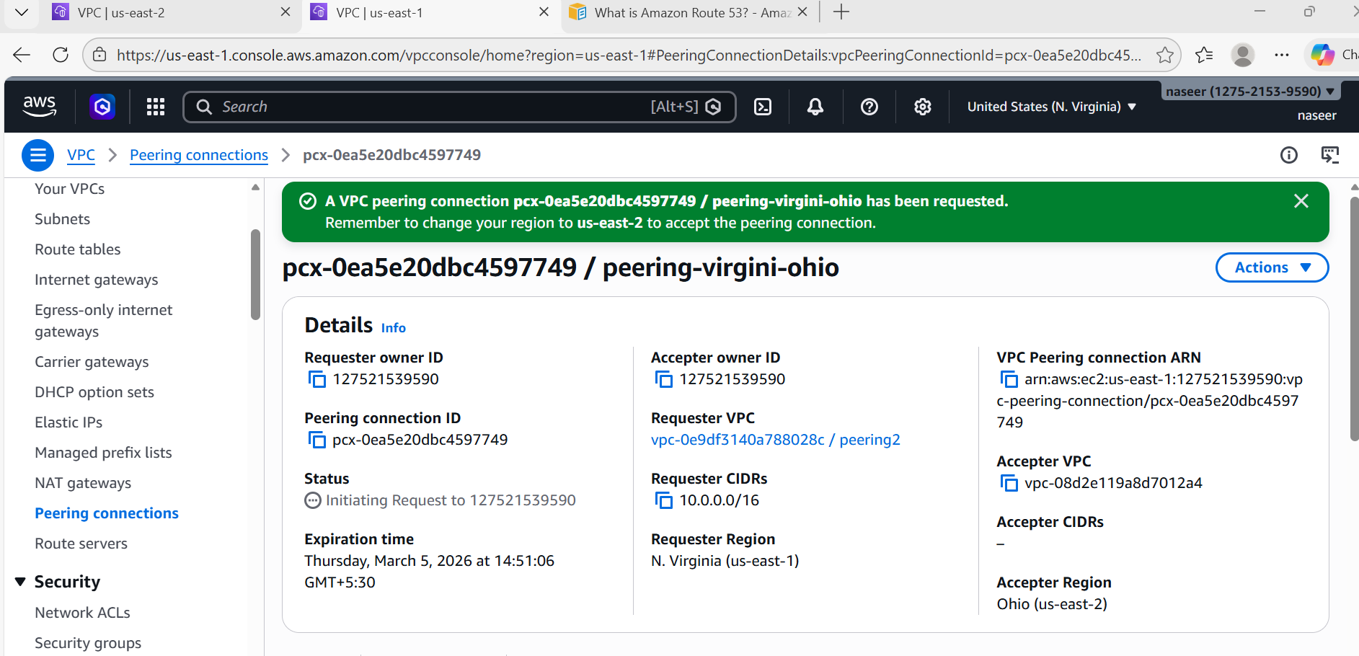

Status: Pending Acceptance
Accept Peering Connection
Switch Region → us-east-2
Go to:
VPC → Peering Connections
Select peering → Click Accept Request
Status becomes: Active

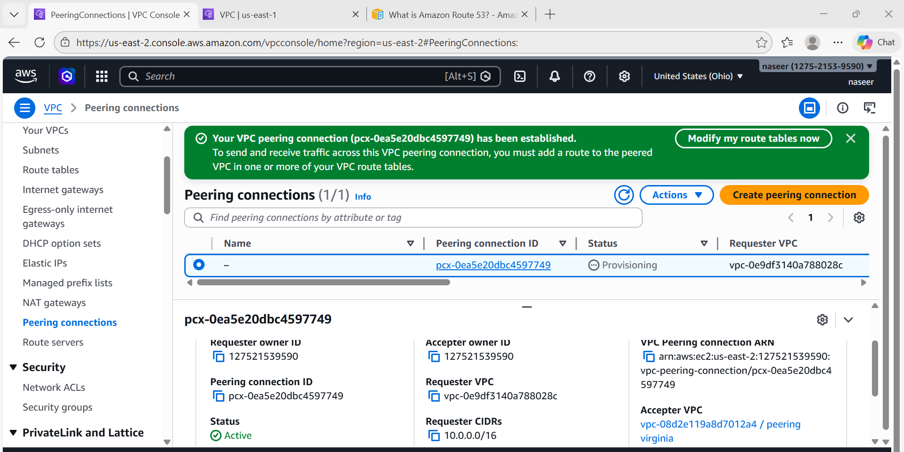
Update Route Table in VPC-1
Go to VPC → Route Tables → Select route table of VPC-1
Click Edit Routes → Add Route
Destination: 192.168.0.0/16
Target: Peering Connection (pcx-id)
Save
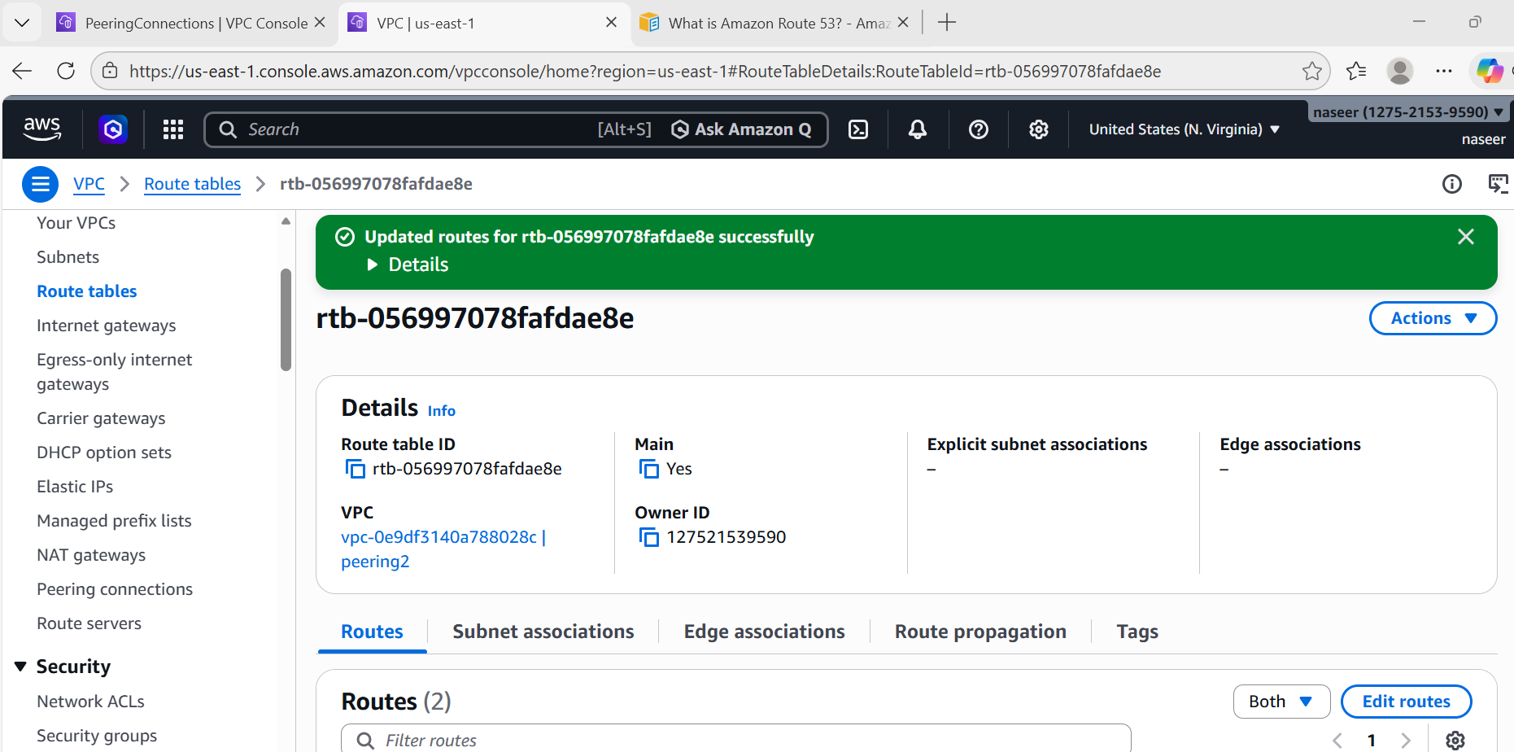
Update Route Table in VPC-2
Switch region → us-east-2
Go to Route Tables → Select route table of VPC-2
Add route:
Destination: 10.0.0.0/16
Target: Peering Connection (pcx-id)
Save
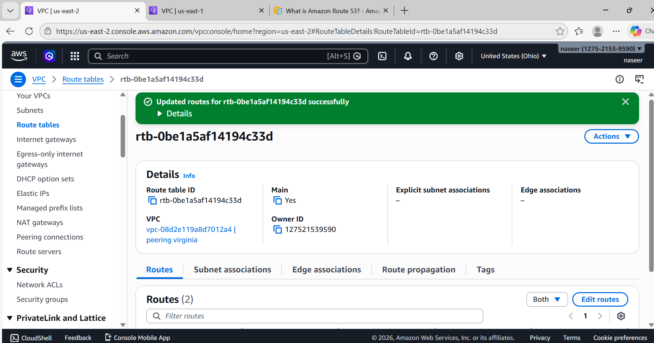
Modify Security Group
Allow traffic between both VPC CIDRs
Example:
In VPC-1 Security Group:
Add inbound rule:
Type: All traffic
Source: 192.168.0.0/16
In VPC-2 Security Group:
Add inbound rule:
Type: All traffic
Source: 10.0.0.0/16
Test Connectivity
Launch EC2 in both VPCs
Try ping:
ping private-ip-of-other-ec2
Success means peering works.
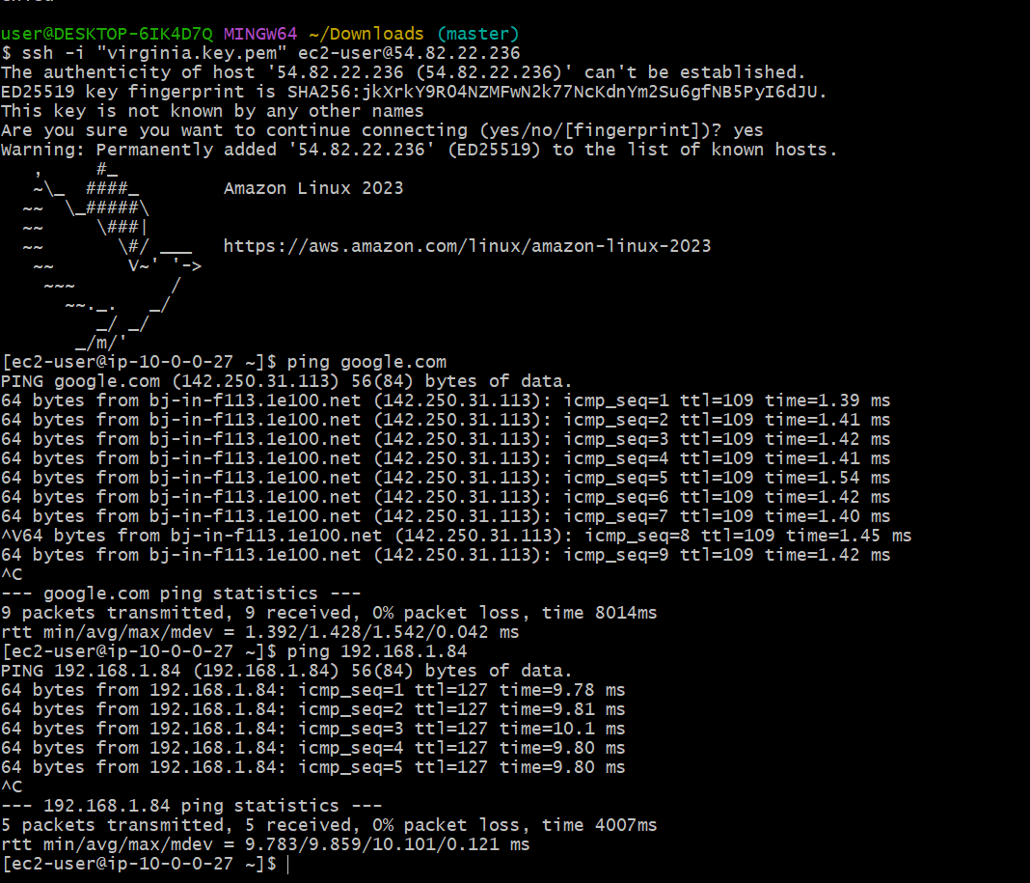
- Purchase one domain from GoDaddy.
STEPS:
https://www.godaddy.com → Create Account
Create account using:
- Email
- Password
Login.
Search for Domain NameIn search box, type your domain name:
Example: babanaseroddin.shopsearchselect a plan(at low cost)
Continue to Cart
Select Domain Duration 1 year Continue to Checkout
Enter Customer Details Name Phone number India AddressCitypin codeSave
Make Payment Select payment method UPI/Credit card/Debit card
Complete Payment
Verify Domain Purchase
Go to GoDaddy → My Products
You will see: babanaserodd.shop
Status: Active
Domain created successfully.
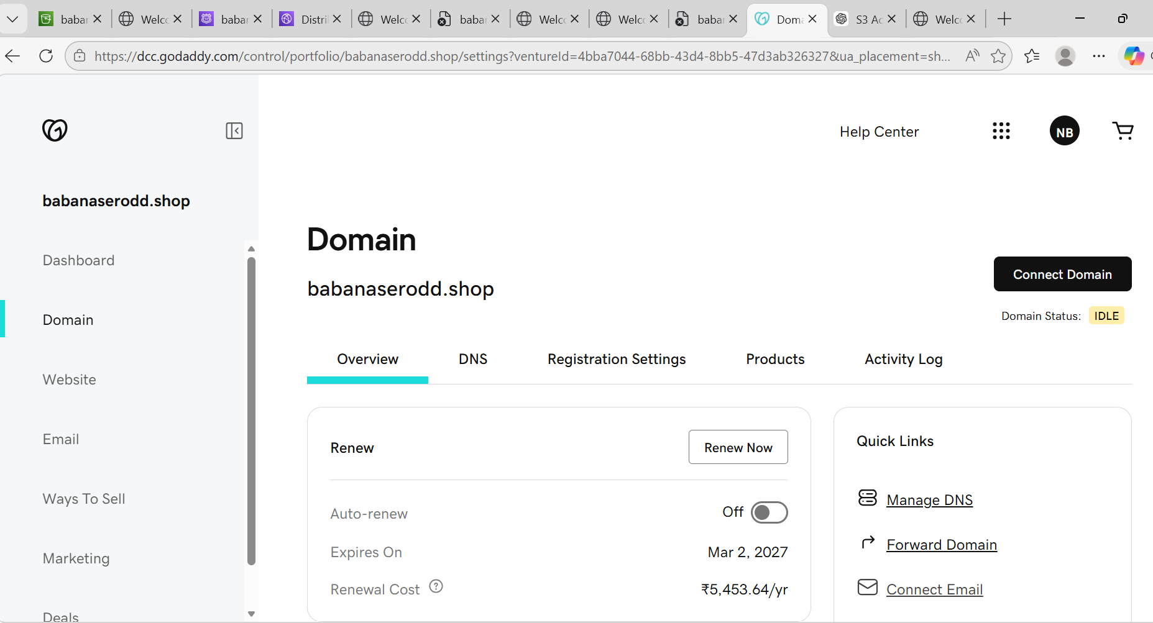
- Deploy static website in S3.
Steps:
- Login to AWS Console
- Go to S3 service
- Click Create bucket
Fill details:
- Bucket name(must be unique globally)
- ❌ Block all public access
Check acknowledgment:
- I acknowledge that the current settings might result in public access
Click Create bucket
Upload Website Files
Example: index.html
Open your bucketClick UploadClick Add filesSelect index.htmlClick Upload
Enable Static Website Hosting
Go to bucketClick PropertiesScroll down toStatic website hostingClick Edit
Select Enable
Fill:
- Index document: index.html
- Error document: index.html
Click Save changes
Go to Bucket → Properties → Static Website Hosting
You will see:
http://babanaserodd2.shop.s3-website-us-east-1.amazonaws.com
Click URL → Website opens

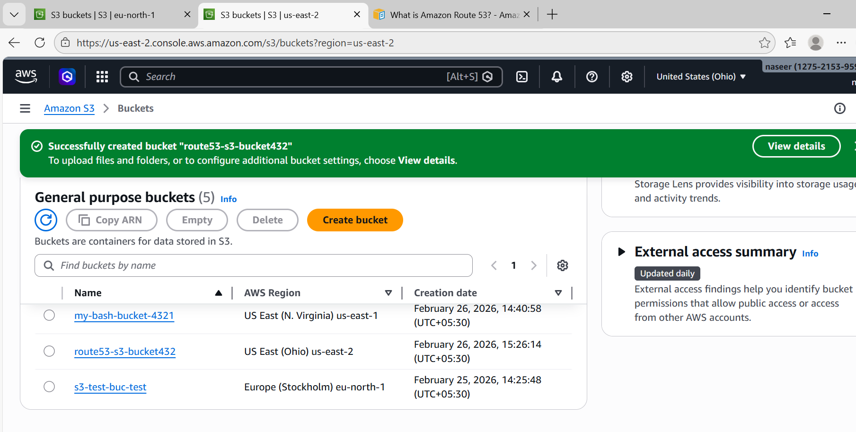
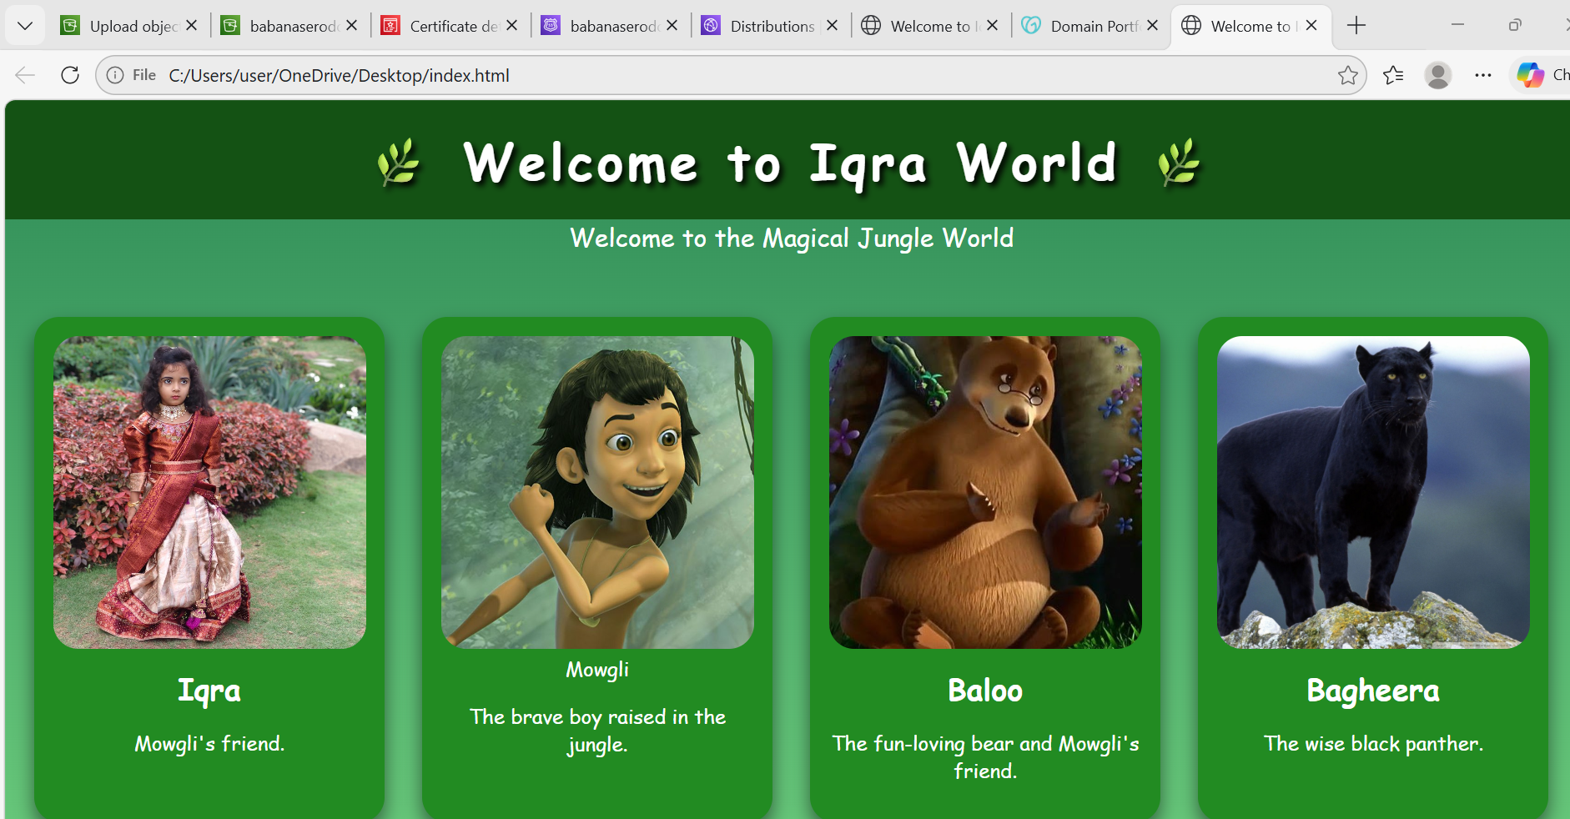
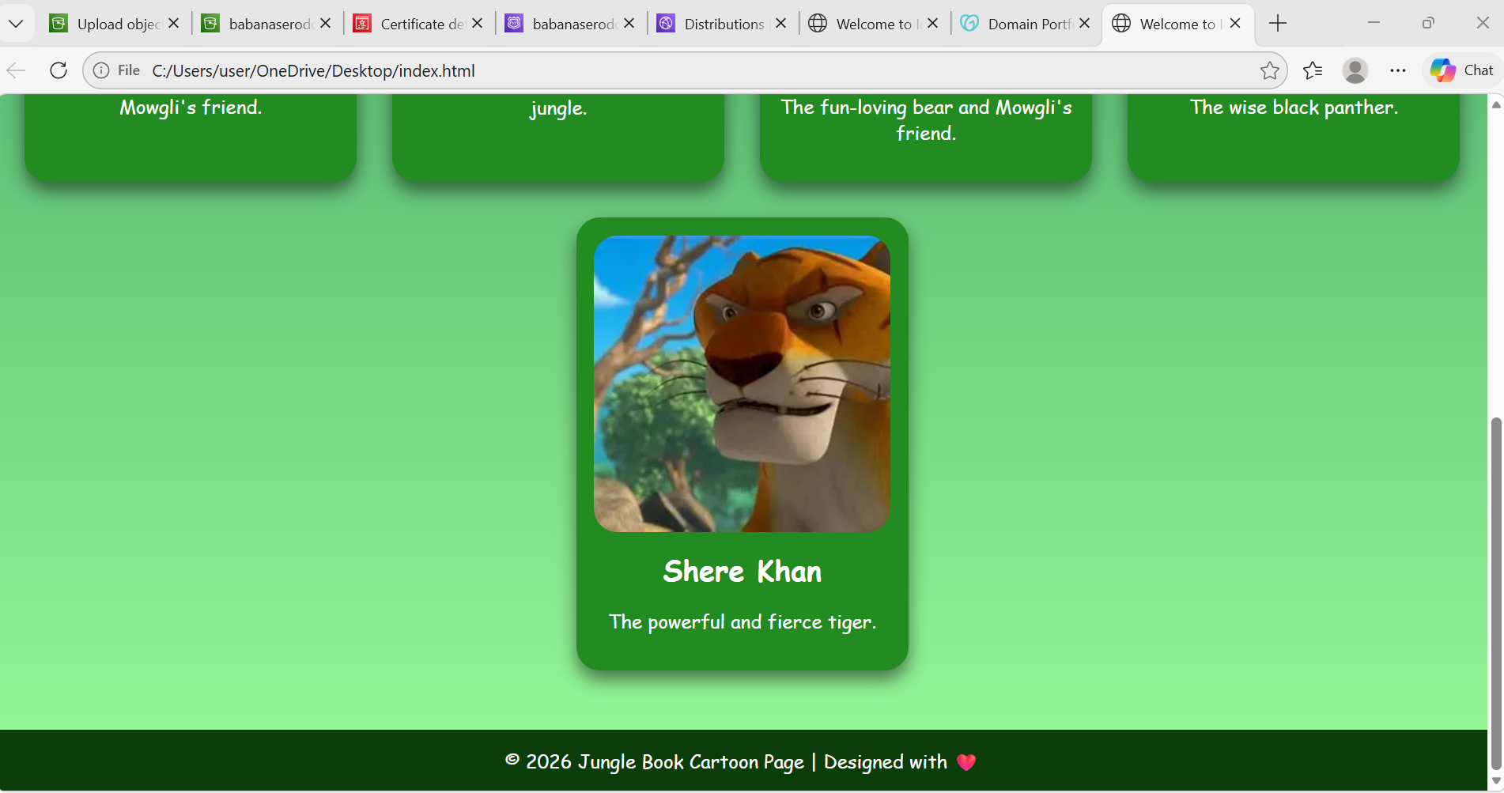
- Create a CDN and attach one SSL certificate.
This has 2 parts:
PART A: SSL Certificate
PART B: CloudFront CDN
PART A: Create SSL Certificate
Steps:
Go to AWS Console Search for Certificate Manager , Request certificate
Request a public certificate Click Next and Enter domain name
Enter: babanasero.shop Click Next after Select validation method
Choose: DNS validation Click Next RequestStatus: Pending validation
Leave this tab open.
PART B: Create CloudFront CDN
Go to AWS Console Search CloudFront Click Create Distribution ,Configure Origin
Origin domain: Select your S3 website endpoint:
Example:
http://babanaserodd2.shop.s3-website-us-east-1.amazonaws.com
Origin protocol:
HTTP only
Configure viewer settings, Viewer protocol policy
Redirect HTTP to HTTPS
Add custom domain
Alternate domain name (CNAME):
Enter:
Babanaserodd.shop
Attach SSL certificate Select Custom SSL certificate and select Create distribution
Wait:
5–10 minutes
Status becomes:
Deployed
Copy:
CloudFront domain
Example:
d3abcxyz.cloudfront.net
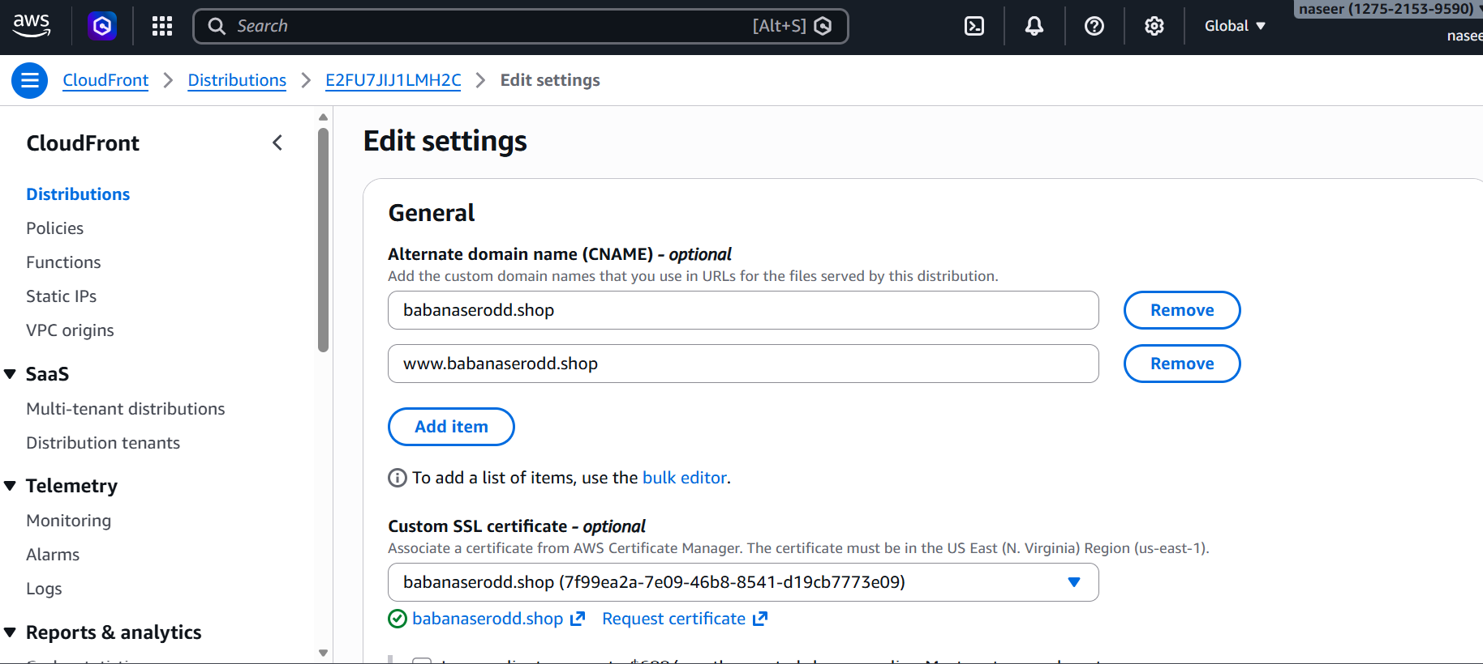
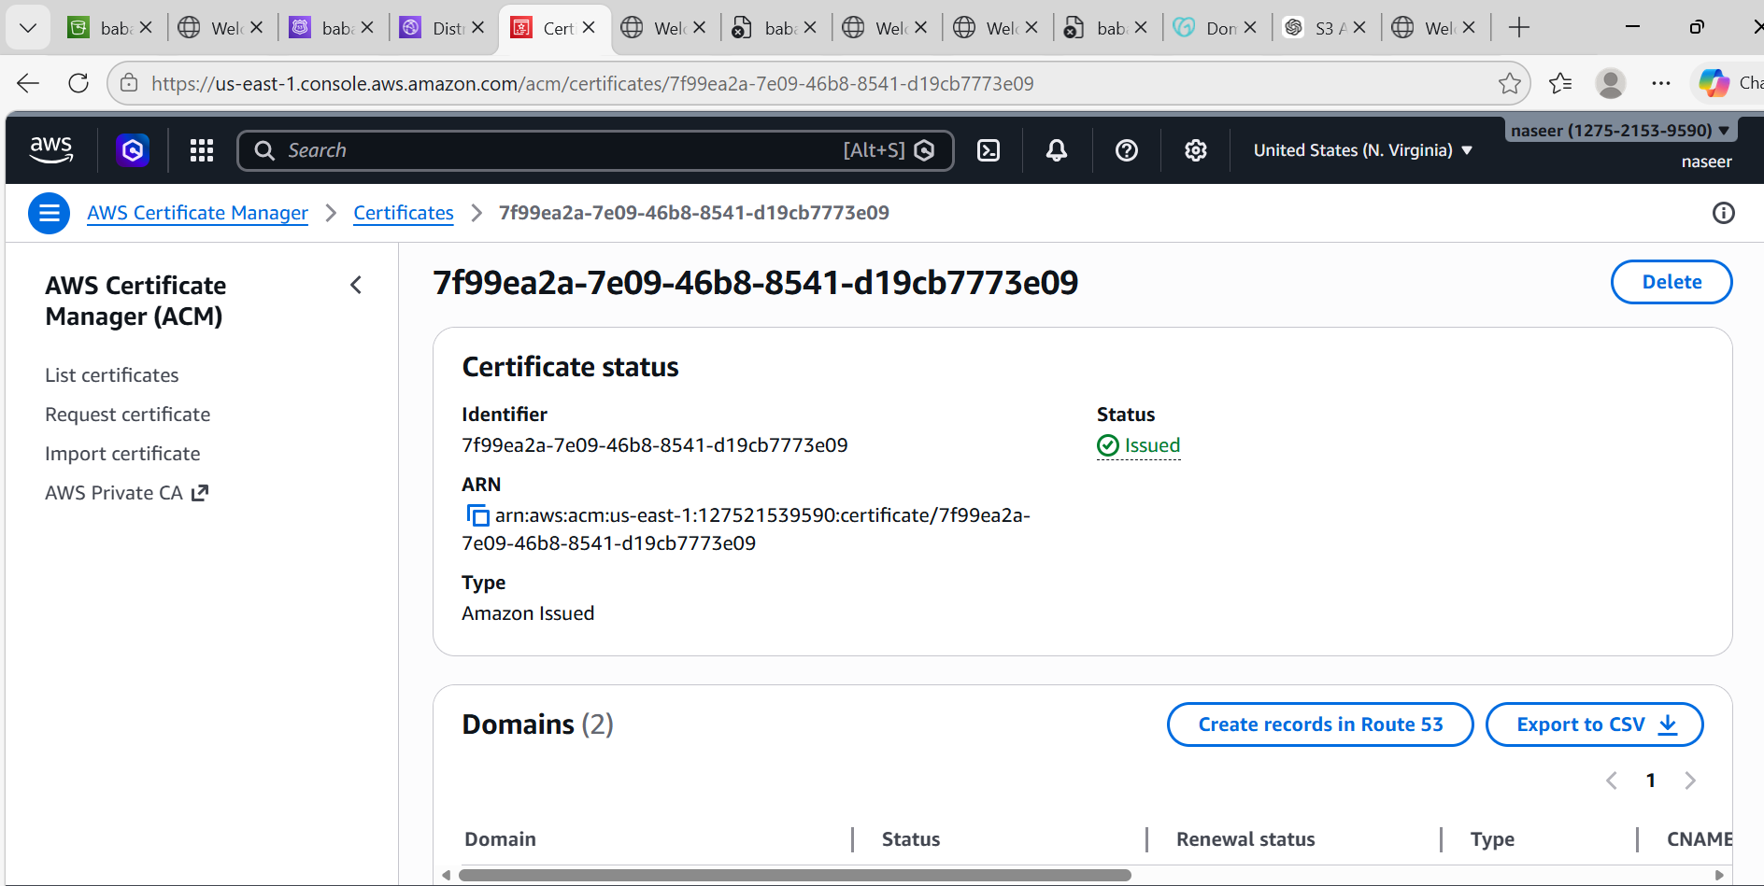
- Create a Route 53 hosted zone and map the domain with the CDN.
Steps:
Login to AWS ConsoleSearch Route 53Click Route 53Click Hosted zones
Click Create hosted zone Fill details:Hosted zone name →
example: babanasero2.shop
Type →Public hosted zoneClick → Create hosted zoneCopy Nameservers
After creating, you will see:
example:
ns-123.awsdns-45.com
ns-456.awsdns-78.net
ns-789.awsdns-12.org
ns-101.awsdns-34.co.uk
Copy all 4 nameservers.
Update Nameservers in GoDaddy
Go to GoDaddy → Domain → DNS → NameserversChange Nameservers
Enter my own nameserversPaste AWS nameservers Click → Save
Wait 5–10 minutes.
Create Record to Connect CloudFront CDN
Go back to Route 53 → Hosted zoneCreate recordFill Record name
wwwRecord type: A
Enable:
Alias = ON
Choose target:
Select:
CloudFront distribution and Choose your CDN distribution. And after Create record
Now domain connects to CDN.
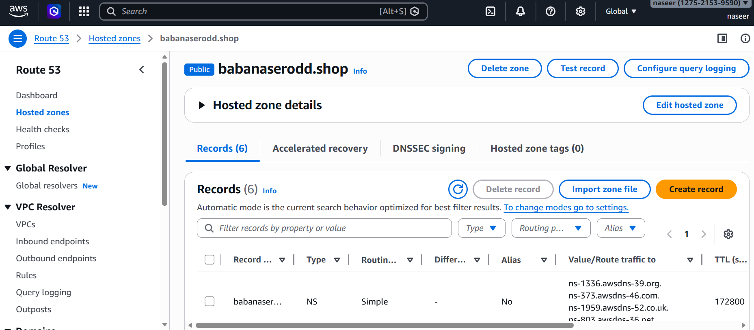
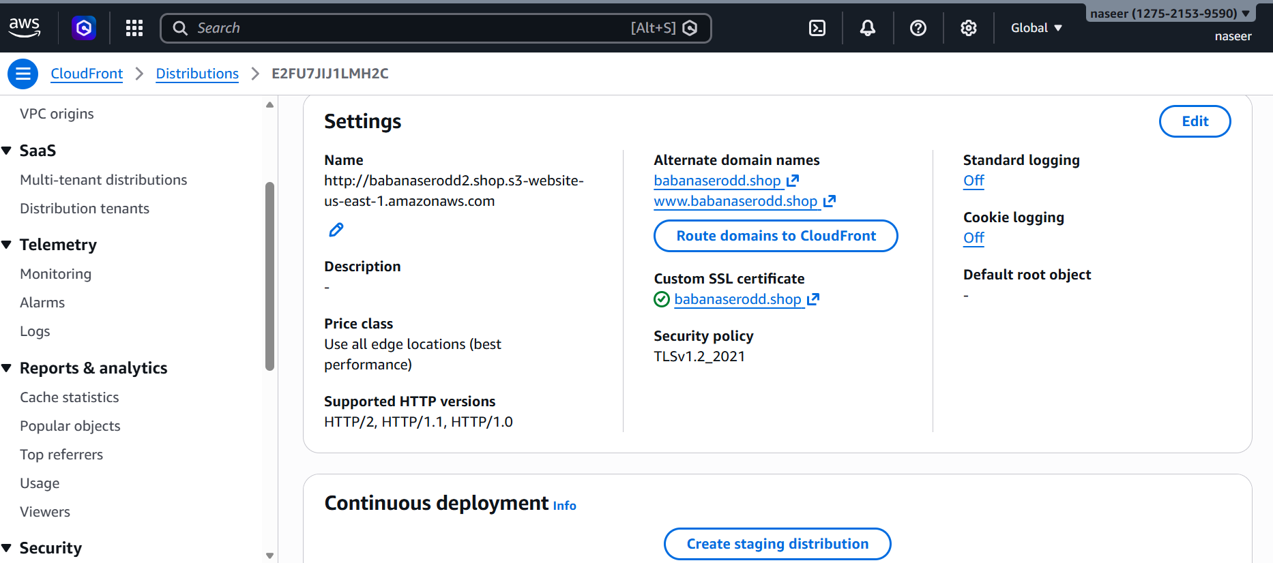

- Update the index.html in the S3 bucket and ensure the updated file is accessible using the domain name.
Steps:
AWS Console → S3 → BucketsClick your bucket babanaserodd2.shop
Upload new index.htmlUploadSelect index.html and upload
Go to Bucket → PermissionsDisableBlock all public accessSave.
Add Bucket Policy
CloudFront → DistributionClick your Distribution IDInvalidations
Create invalidationEnter:/*Create invalidationNow CDN refreshes.
Test DomainAfter 5–10 minutes open:
https://www.babanasero.shop
Your website will open.
Final Architecture (Complete Flow)
User
↓
Domain (GoDaddy)
↓
Route 53
↓
CloudFront (CDN + SSL)
↓
S3 Bucket
↓
index.html
Checklist (Verify)
✔ Domain purchased
✔ Hosted zone created
✔ Nameservers updated
✔ CloudFront created
✔ SSL attached
✔ Route53 record created
✔ S3 index.html uploaded
✔ Cache invalidated
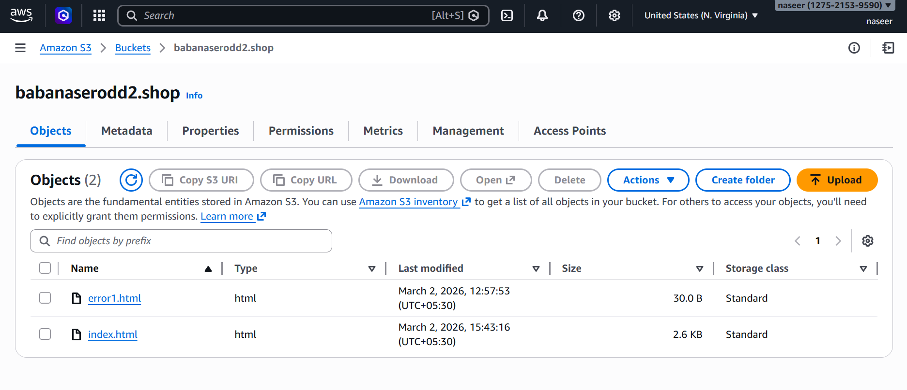
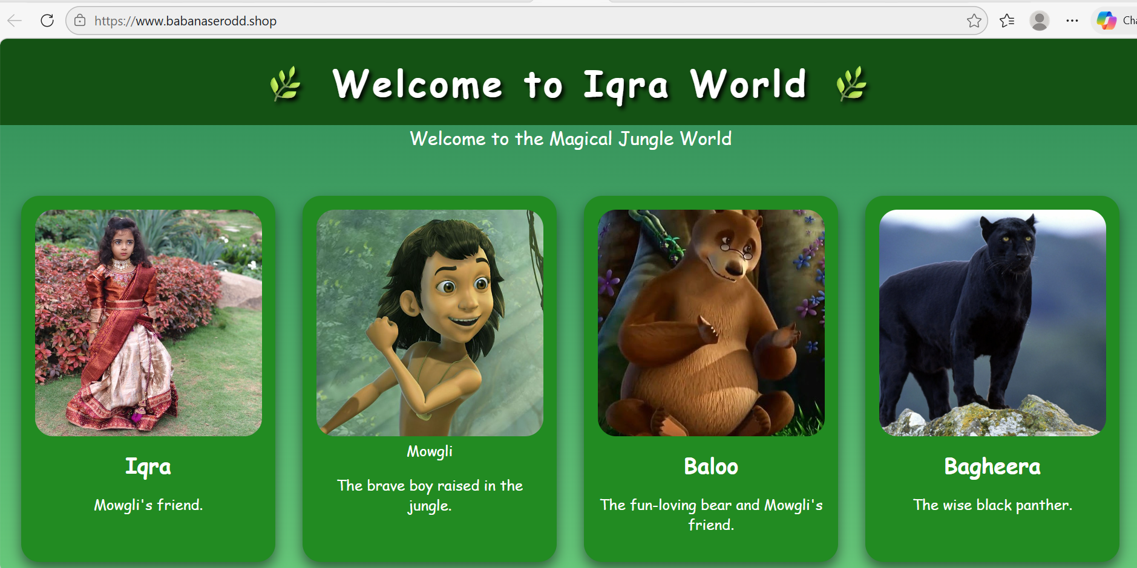
- Share the domain name in Slack to test the connectivity.
Welcome to Iqra World
https://www.babanaserodd.shop/

